Software Design Document


Child Vaccination Management System
Final Year Project
Prepared By: Faria Batool
Supervisor:SIR MUZAMMIL-UR-REHMAN

TABLE OF CONTENTS
- Introduction
- Purpose of the Document
- Scope of the System
- Definitions, Acronyms, and Abbreviations
- System Overview
- System Architecture Design
- Technology Stack
- User Roles and Permissions
- Functional Requirements
- Non-Functional Requirements
- Module Design
- Data Design (Local Storage / Database)
- User Interface Design
- UML Diagrams
- Security Considerations
- Error Handling
- Future Enhancements
- Conclusion

1. INTRODUCTION
The Child Vaccination Management System is a web-based healthcare application designed to manage child vaccination records digitally. The system helps healthcare staff record vaccination details, calculate next dose schedules automatically, generate vaccination certificates, and maintain secure and organized records.
This system is especially useful for clinics and vaccination centers where manual record-keeping is time-consuming and error-prone.

2. PURPOSE OF THE DOCUMENT
The purpose of this Software Design Document (SDD) is to describe the architecture, components, data flow, and design decisions of the Child Vaccination Management System. This document serves as a reference for developers, evaluators, and instructors to understand how the system is designed and implemented.

3. SCOPE OF THE SYSTEM
The scope of the system includes:
- Secure login for medical staff
- Role-based access (Admin and Nurse)
- Add, edit, delete vaccination records
- Auto calculation of next vaccination date
- Export vaccination data to Excel
- Generate vaccination certificates in PDF
- Generate separate Polio certificates
- QR code generation for verification
- Dashboard with statistics and charts
The system works on a client-side web environment using browser storage.

4. DEFINITIONS, ACRONYMS, AND ABBREVIATIONS
- SDD: Software Design Document
- UI: User Interface
- PDF: Portable Document Format
- QR Code: Quick Response Code
- Admin: User with full system privileges
- Nurse: User with limited access

5. SYSTEM OVERVIEW
The system is a single-page web application developed using HTML, CSS, and JavaScript. It provides a modern medical-themed interface with interactive dashboards, pop-ups, charts, and downloadable certificates.
Data is stored locally in the browser using localStorage, ensuring quick access without internet dependency.

6. SYSTEM ARCHITECTURE DESIGN
The system follows a client-side layered architecture:
- Presentation Layer
Handles UI elements such as login page, dashboard, tables, and modals.
- Application Logic Layer
Manages validation, next dose calculation, record processing, and role-based access.
- Data Storage Layer
Stores vaccination records using browser localStorage.

7. TECHNOLOGY STACK
- HTML5 – Structure of the application
- CSS3 – Styling and medical theme design
- JavaScript (ES6) – Application logic
- Chart.js – Graphical data visualization
- jsPDF – PDF certificate generation
- QRCode.js – QR code generation

8. USER ROLES AND PERMISSIONS

Admin
- Add vaccination records
- Edit vaccination records
- Delete vaccination records
- Export data to Excel
- Generate certificates

Nurse
- View vaccination records
- Generate certificates
- Cannot add or delete records

9. FUNCTIONAL REQUIREMENTS
- The system shall allow users to log in using role selection.
- The system shall allow Admin to add child vaccination records.
- The system shall allow editing and deleting records.
- The system shall automatically calculate next vaccination date.
- The system shall generate PDF certificates with stamp and QR code.
- The system shall generate separate Polio certificates.
- The system shall export vaccination records to Excel.
- The system shall display dashboard statistics and charts.

10. NON-FUNCTIONAL REQUIREMENTS
- The system shall have a professional medical-themed UI.
- The system shall respond within acceptable time limits.
- The system shall be easy to use for non-technical staff.
- The system shall maintain data integrity.
- The system shall be scalable for future backend integration.

11. MODULE DESIGN

Login Module
Handles user authentication and role assignment.

Dashboard Module
Displays total children, vaccines administered, upcoming doses, and charts.

Record Management Module
Allows adding, editing, deleting, and searching vaccination records.

Certificate Module
Generates PDF vaccination certificates with QR code and stamp.

Export Module
Exports vaccination records to Excel format.

12. DATA DESIGN
Each vaccination record contains:
- Child Name
- Vaccine Name
- Vaccination Date
- Next Dose Date
Data is stored as JSON objects in browser localStorage.

13. USER INTERFACE DESIGN

Login Page
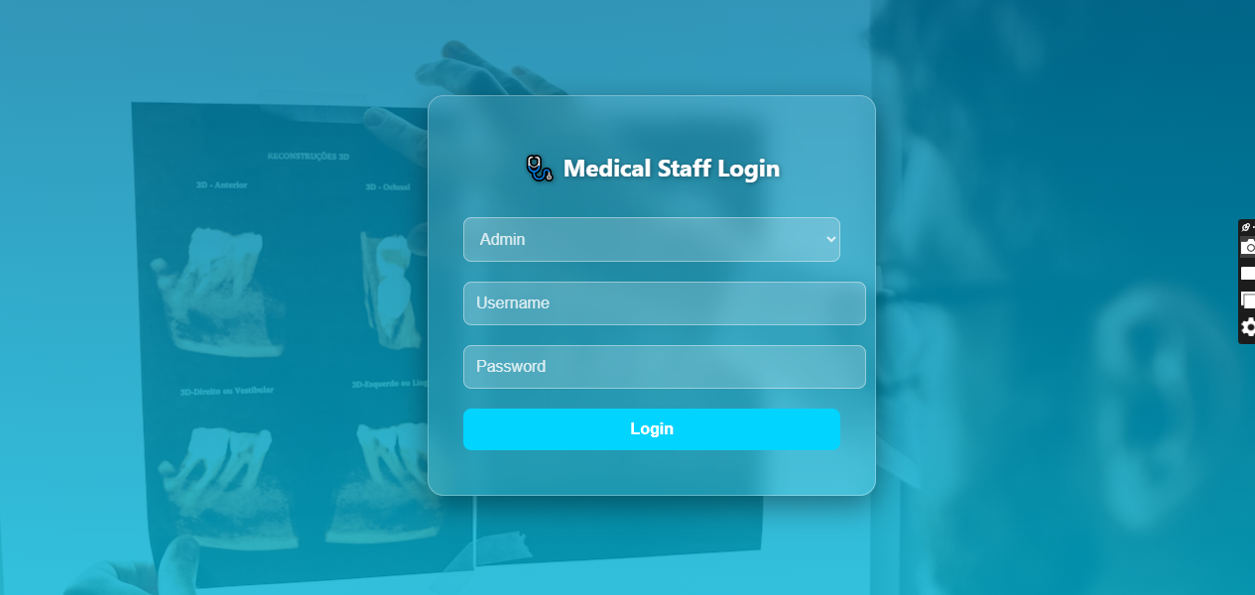
The login page features a medical background image, role selection, and secure input fields.

Dashboard / Home Page
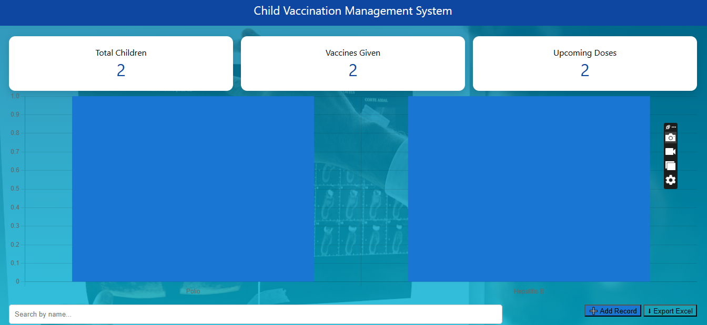
The dashboard displays cards, charts, and record statistics.

Record Management Page
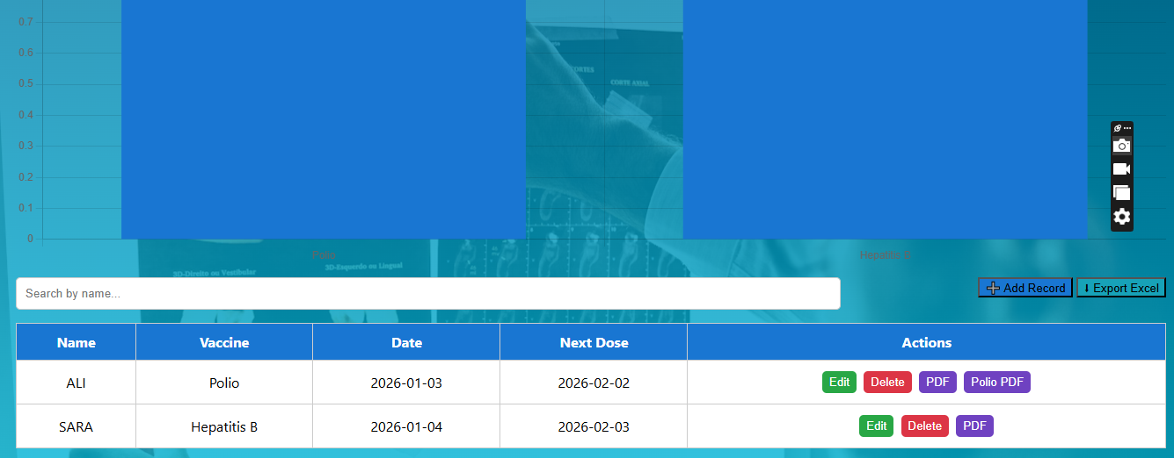
Displays vaccination records in a table with action buttons.

14. UML DIAGRAMS

Use Case Diagram
Shows interactions between Admin/Nurse and system features.

Class Diagram

Represents system entities such as User, Record, Certificate.

Sequence Diagram
Shows step-by-step flow of adding a vaccination record.

Activity Diagram
Represents workflow from login to certificate generation.
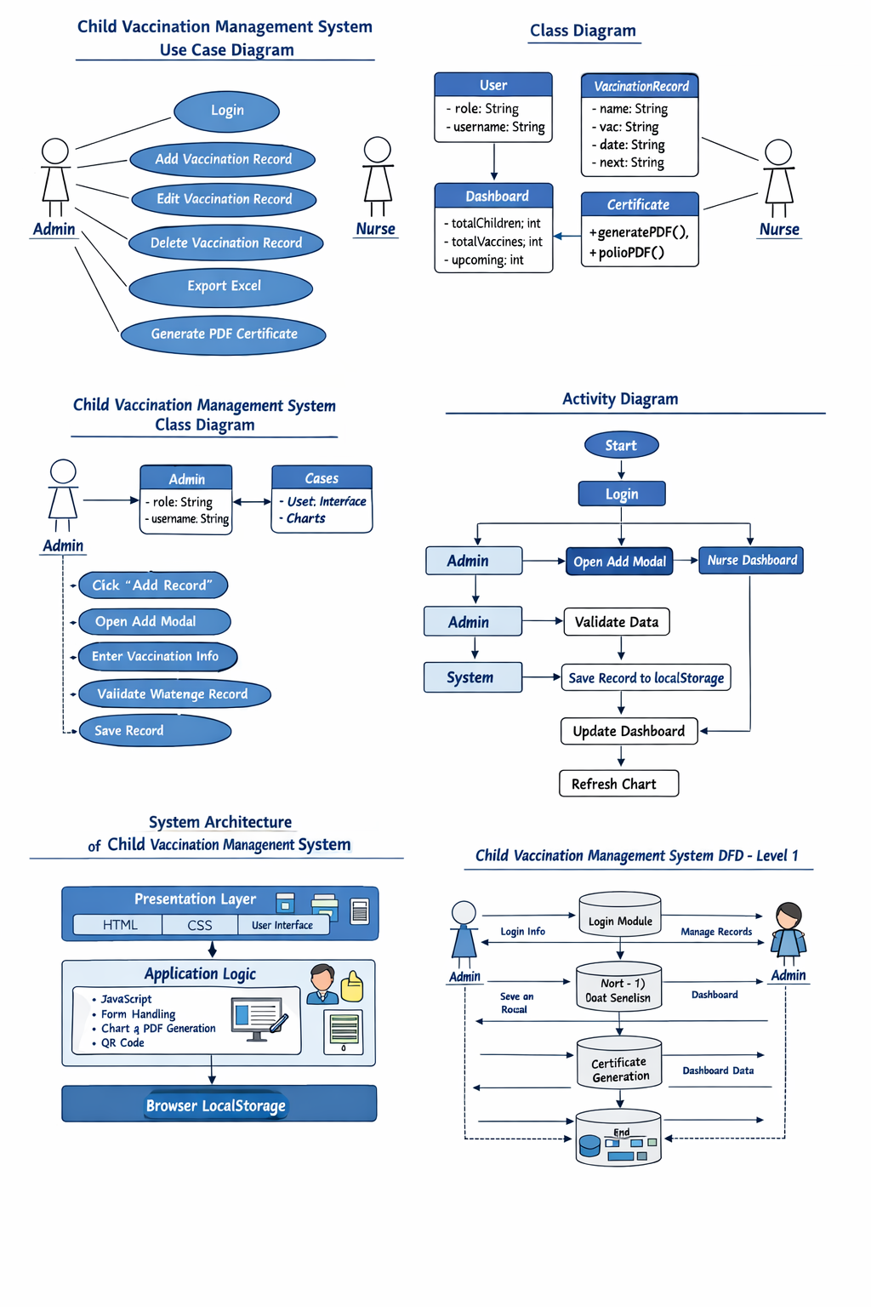

15. SECURITY CONSIDERATIONS
- Role-based access control
- Input validation
- Restricted editing for nurse role
- Local data isolation per browser

16. ERROR HANDLING
- Alerts for empty input fields
- Validation for incorrect data
- Toast notifications for actions
- Confirmation dialogs for deletion

17. FUTURE ENHANCEMENTS
- Backend integration (Node.js + MongoDB)
- Online database support
- Multi-clinic support
- SMS reminders for next dose
- Admin analytics dashboard

18. CONCLUSION
The Child Vaccination Management System provides a reliable, user-friendly, and professional solution for managing vaccination records digitally. The system improves efficiency, reduces manual errors, and ensures accurate vaccination tracking.

